Spring Core – Load SimpleDateFormat from Spring Configuration XML
Created and configured the date-format configuration file
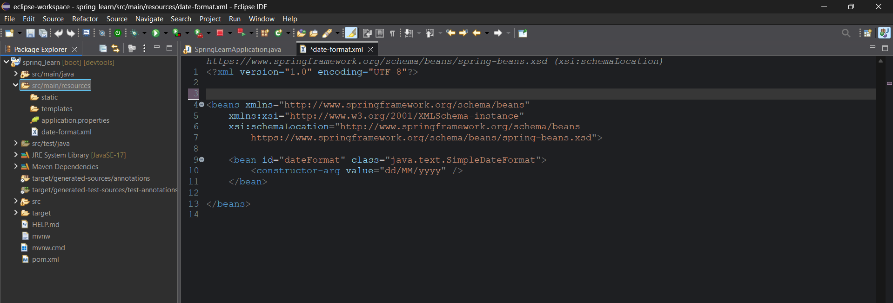
Created the displayDate method in the main file.
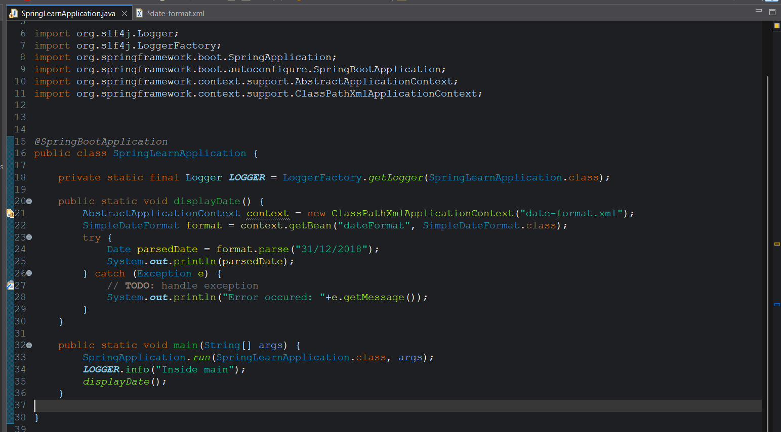

Output:
